Update on Cambridge University plans for Brain Imaging Research
September 2020

Dear autism community,

We are a research team at the University of Cambridge led by Dr. Alex Woolgar. Our team is interested in how non-speaking autistic people understand spoken language. We would like to study this using brain imaging. In this short newsletter, we want to inform people on where the research is up to, and ask autistic non-speakers for feedback and input on our research plans.

Research preparation
The very new approach taken in this research – using brain imaging to look at information processing in the brain – has taken a few years to develop. We have spent the last 5 years working with typically developing children and their families, as well as with a few key RPM students in Australia, to develop child-friendly paradigms, and find the most suitable brain imaging technologies, and sensitive analytical methods for the research. We have recently had 3 papers on this work published in scientific journals. Next, we will need your input to make our tests suitable for non-speaking autistic people.

The impact of COVID-19
The pandemic has meant that we have had to put a lot of our research on hold. In particular, we had to halt all in-person data collection in March. However, now that the world is learning more about the virus and how to control it, we’re looking into how we can safely re-commence testing later this year. Meanwhile we’re excited to hear from nonspeakers with any feedback they have or input they’d like to have into our research. We have put together a short list of questions for you to respond to if you would like to. Questions are found at the end of this letter.
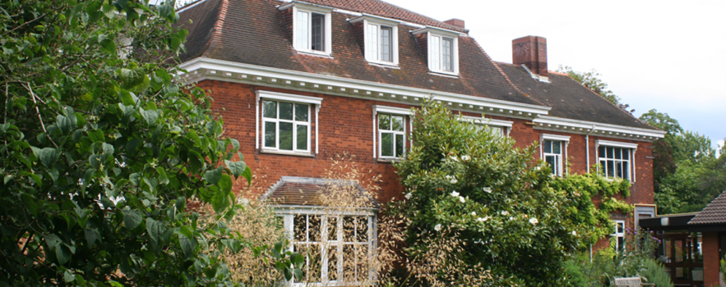

The MRC Cognition and Brain Sciences Unit in Cambridge
What inspired our research?
Dr Woolgar became interested to study the abilities of non-speaking autistic people after working with a 6-year-old child using the Rapid Prompting Method (RPM). The child, we’ll call her Lucy (not her real name), didn’t speak yet at that time, but through RPM she showed that she was smart, imaginative and thoughtful. The experience changed Dr Woolgar’s understanding of how well Lucy understood spoken language and made her question the scientific understanding of autism – which frequently assumes that children who do not speak also do not understand.

What are the main goals of the research?
We would like to learn more about how non-speaking peoples’ brains processes spoken words, using brain imaging technologies that are gentle and fast to set up. The aim of our research is to provide a chance for non-speaking autistic people to demonstrate how well they understand word meanings without relying on speech or behaviour. We hope to achieve this by creating suitable, reliable brain imaging measures that can be used as a marker of language processing.

What happens next?
The next step will be to establish whether our brain imaging approach can be used effectively to study receptive language processing in autistic individuals who do not speak, or speak unreliably, but do understand language - such as children who use RPM.

What is the research method?
We will be using Electroencephalography (EEG) which uses electrodes on the scalp to measure the tiny electrical impulses caused by neurons firing in the brain. We record these tiny signals while people listen to spoken words and sentences. We’re working to develop the brain imaging technology, our paradigms, and our analysis methods, to be sensitive enough to detect brain responses that reflect understanding language. One way we are trying to do this is by comparing the brain responses to sentences that do and do not make sense.

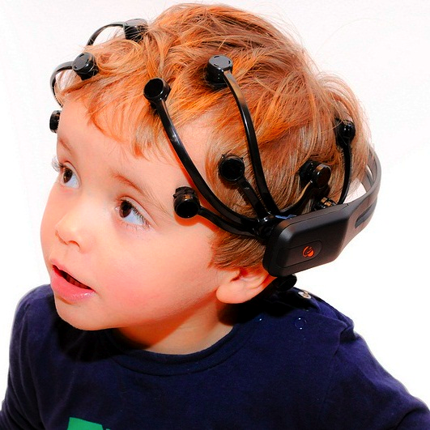

One of the headsets we have been using to record brain activity. Picture from manufacture’s website.

We would like to hear from you. Here are our questions.
Please fill in your responses under each question and email them to Alyse.brown@mrc-cbu.cam.ac.uk

Question 1. Describe the ways in which you yourself communicate. How would you characterise your spoken language?

Question 2. What makes communication easy or hard for you?

Question 3. What do you anticipate might be the challenges of participating in brain imaging research? If you were designing the research protocol what would your method look like?

Question 4. What would you like to tell researchers and scientists – that they might not realise - about how your brain and body works to communicate?

Question 5. What would you like researchers in Cambridge to study, in the future, about the brains of non-speakers? Why?

Question 6. Would you yourself be interested to take part in brain imaging research? Why/Why not?

Question 7. Please tell us:
- How many years old are you?
- What state/county and country do you live in?

Question 8. Parents and communication partners, do you have any comments you would like to share?

We will shortly be recruiting participants for our first study* with non-speakers. If you would like us to send you details of this study, please say so in your email to Alyse.brown@mrc-cbu.cam.ac.uk or fill out the form on our website: https://www.woolgarlab.org/hidden-ability-in-autism.

*Our first study is for children age 5-15 who live in the UK or in New South Wales, Australia. However, we are working to be able to include people aged 16 and over, and other states and countries, in the future - so we would love to hear from you as well!

We hope that you are all staying safe, happy and healthy.
Dr. Alex Woolgar, Dr. Alyse Brown, and Dr. Selene Petit
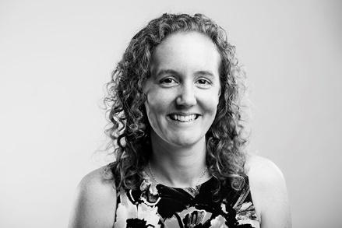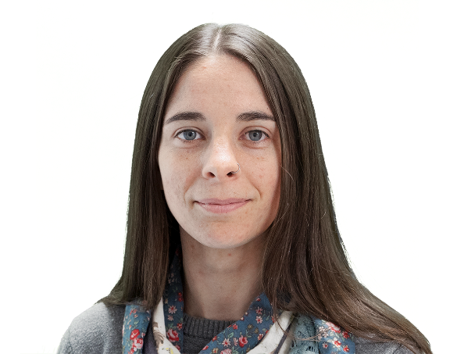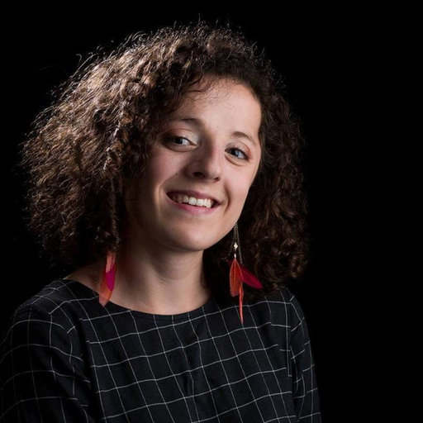
www.woolgarlab.org

